EXPERIMENT

**AIM:** To design visitor counting system with the help of LDR for a hall. Assume that only one person can pass through the door at any time and also there are seprate entry and exit doors . Note: The visitor count needs to be displayed on the serial monitor at all times .

**APPARATUS:**Arduino,resistor(10K,22O),wire ,breadboard,LDR.

**CIRCUIT DIAGRAM:** 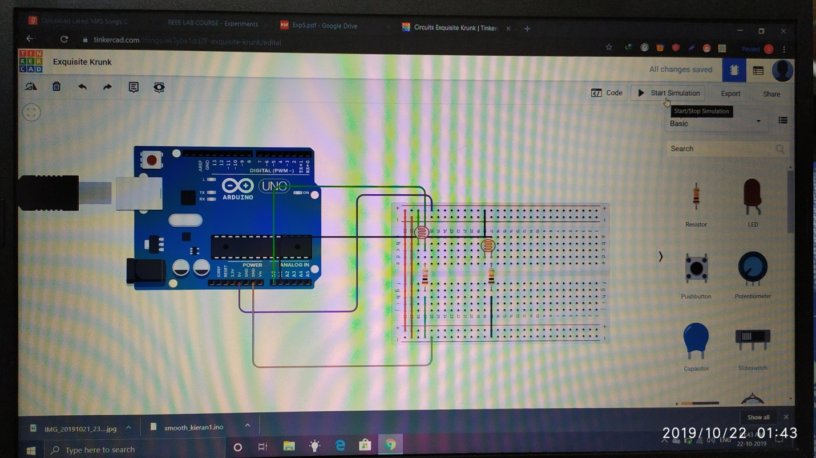

**PROGRAM:**

#define LDR_1 A0

#define LDR_2 A1

const int LDR_Min=950;

bool LDR1=LOW;

bool LDR2=LOW;

int PeopleNumber=0;

void setup() {

// put your setup code here, to run once:

Serial.begin(9600);

}

void loop() {

// put your main code here, to run repeatedly:

if(analogRead(LDR_1)<LDR_Min && analogRead(LDR_2)>LDR_Min && LDR1==LOW && LDR2==LOW)

LDR1=HIGH;

if(analogRead(LDR_1)>LDR_Min && analogRead(LDR_2)<LDR_Min && LDR1==HIGH && LDR2==LOW)

{

while(analogRead(LDR_2)<LDR_Min)

{ }

PeopleNumber++;

Serial.println("People in room: " + (String)PeopleNumber);

LDR1=LOW;

LDR2=LOW;

}

if(analogRead(LDR_1)>LDR_Min && analogRead(LDR_2)<LDR_Min && LDR1==LOW && LDR2==LOW)

LDR2=HIGH;

if(analogRead(LDR_1)<LDR_Min && analogRead(LDR_2)>LDR_Min && LDR1==LOW && LDR2==HIGH)

{

while(analogRead(LDR_1)<LDR_Min)

{ }

PeopleNumber=PeopleNumber>0?PeopleNumber-1:0;

Serial.println("People in room: " + (String)PeopleNumber);

LDR2=LOW;

LDR1=LOW;

}

}

**RESULT:**

Counted visitor with the help of LDR for a hall.